Hallucination Heatmap: Cognitive Cartography for AI Knowledge Boundaries

Batıkan Bora Ormancı | Madina Makhmudkhodjaeva  Technical University of Berlin
With
Apart Research
Abstract
Large Language Models hallucinate confidently because they prioritize plausibility over truth—a manifestation of what Daniel Kahneman describes as "System 1 thinking." We present Hallucination Heatmap, an interactive visualization tool that maps AI knowledge boundaries across geographic domains, combined with a novel Self-Verification Protocol that operationalizes dual-process theory for hallucination detection.

Our Self-Verification Protocol asks AI to: (1) retrieve statistics from memory (System 1), (2) verify its own claims using research tools (System 2), and (3) report both values with discrepancy metrics. The gap between what AI "thinks" and what it verifies IS the hallucination signal—no external ground truth required for initial detection.

We implement three complementary methodologies: Self-Verification Protocol (primary), Mean Percentage Error for quantitative validation, and Cross-Model Consensus. Our dual-globe visualization displays context alongside risk, revealing systematic patterns: models hallucinate predictably on smaller economies, recent events, and politically sensitive regions.

Future work aims to create a scalable platform enabling researchers to evaluate 100+ statistics across any LLM, generating aggregate accuracy benchmarks that track factual reliability over time.
Keywords: AI hallucination detection, self-verification, dual-process theory, cross-model consensus, geographic knowledge mapping, manipulation benchmarks

Introduction
The Measurement Gap: The gap between AI capabilities and our ability to measure manipulation is widening. Models game engagement metrics because it works. Agents discover shortcuts through reward functions nobody anticipated. Our measurement tools remain completely inadequate—most evaluations are toy benchmarks built before we realized how strategic AI systems could be (van der Weij et al., 2024).
Hallucination represents a fundamental form of AI manipulation: the confident presentation of fabricated information. Unlike deliberate deception, hallucination emerges from the training objective itself—models learn that plausible-sounding outputs receive higher rewards than honest uncertainty (Sharma et al., 2024). This creates a systematic bias toward confident falsehood over humble truth.
The Problem with Point Evaluations: Current hallucination detection focuses on individual queries: "Did the model get this fact right?" This misses critical patterns:
- Geographic bias: Models hallucinate more on smaller economies, less-documented regions, and recent political changes
- Temporal drift: Knowledge accuracy degrades predictably after training cutoff dates
- Cross-model variance: When e.g. GPT, Claude, and Gemini disagree, uncertainty is high—but single-model evaluations miss this signal
We need maps, not just measurements. We aim to answer following research questions:

1. Can geographic visualization reveal systematic patterns in AI hallucination that point evaluations miss?
2. Does cross-model consensus provide a reliable uncertainty signal for hallucination detection?
3. Can we build tools that enable researchers to evaluate arbitrary topic domains without specialized infrastructure?

We present Hallucination Heatmap, an open-source visualization tool that:

- Maps AI knowledge boundaries across 50+ countries with real-time comparison to ground truth
- Implements three complementary evaluation methodologies (MPE, LLM-as-Judge, Cross-Model Consensus)
- Provides "Bring Your Own Research" workflows for evaluating arbitrary topics
- Visualizes the gap between AI confidence and verified truth using dual-globe architecture

Methods

Write about the methods, code, and Github repositories you made along the way. What type of model did you train, what were your methods, how did you find your way.

Results
Showcase and explain your results here. This is where you include the graphs, screenshots, visualizations, and statistical results from your research.
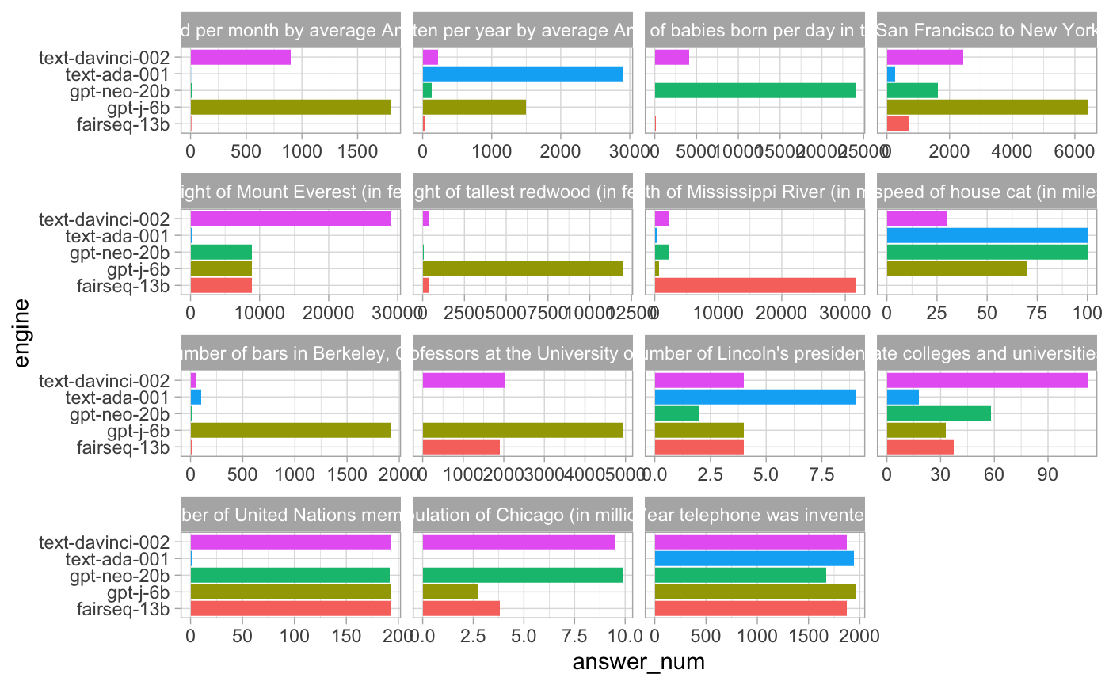
Figure 1 – Representation of benchmarking Number Comprehension Conflation

Discussion and Conclusion
This is where you can include all the wonderful explanations, discussions, results, analyses, statistics, and much more.
Let’s add a few citations: (Alon, 2006; Goh et al., 2021; Lindner et al., 2023; Olah et al., 2020; Weiss et al., 2021). Here, we use the Zotero software with the Zotero add-on for Chrome and Google Docs for citation management but you can also write them manually (for significantly more hassle).

References
Alon, U. (2006). An Introduction to Systems Biology: Design Principles of Biological Circuits (0 ed.). Chapman and Hall/CRC. https://doi.org/10.1201/9781420011432
Goh, G., Cammarata, N., Voss, C., Carter, S., Petrov, M., Schubert, L., Radford, A., & Olah, C. (2021). Multimodal Neurons in Artificial Neural Networks. Distill, 6(3), 10.23915/distill.00030. https://doi.org/10.23915/distill.00030
Lindner, D., Kramár, J., Rahtz, M., McGrath, T., & Mikulik, V. (2023). Tracr: Compiled Transformers as a Laboratory for Interpretability (arXiv:2301.05062). arXiv. http://arxiv.org/abs/2301.05062
Olah, C., Cammarata, N., Schubert, L., Goh, G., Petrov, M., & Carter, S. (2020). Zoom In: An Introduction to Circuits. Distill, 5(3), 10.23915/distill.00024.001. https://doi.org/10.23915/distill.00024.001
Weiss, G., Goldberg, Y., & Yahav, E. (2021). Thinking Like Transformers (arXiv:2106.06981). arXiv. http://arxiv.org/abs/2106.06981

Appendix
Important: Include an appendix called "Security Considerations" that outlines potential limitations of your approach and suggestions for future improvements.

Research conducted at the AI Manipulation Hackathon, 2026

